INTERNSHIP REPORT

Submitted by
ARYA MENON RA2211003020053

Under supervision of
RAKESH PAUL
KPMG India
(Duration: 6 months )

In partial fulfillment for the award of the degree
of

BACHELOR OF TECHNOLOGY
in

COMPUTER SCIENCE AND ENGINEERING
of

FACULTY OF ENGINEERING AND TECHNOLOGY

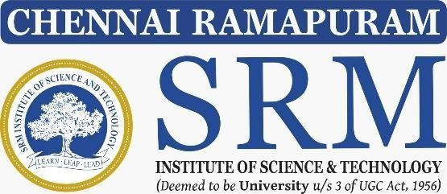

SRM INSTITUTE OF SCIENCE AND TECHNOLOGY RAMAPURAM , CHENNAI-600089
APRIL 2026

SRM INSTITUTE OF SCIENCE AND TECHNOLOGY

(Deemed to be University Under Section 3 of UGC Act, 1956)

BONAFIDE CERTIFICATE

This is to certify that the “21CSP403L - INTERNSHIP REPORT” submitted by ARYA MENON (Reg. No. RA2211003020053) is the work done by her and submitted during 2025 – 2026 academic year, in partial fulfillment of the requirements for the award of the degree of BACHELOR OF TECHNOLOGY in COMPUTER SCIENCE AND ENGINEERING, SRM Institute of Science and Technology, Ramapuram at KPMG India, Bangalore.

INTERNSHIP COORDINATOR HEAD OF THE DEPARTMENT

Dr.K.SUJATHA M.E , Ph.D., Dr.K.RAJA M.E, Ph.D.,
Assistant Professor, Professor and HOD,

Department of Computer Science and Engineering,
SRM IST Ramapuram Campus, Chennai.
Department of Computer Science and Engineering,
SRM IST Ramapuram Campus, Chennai.

ACKNOWLEDGEMENT

I place on record my deep sense of gratitude to our lionized Chairman Dr. R. SHIVAKUMAR for providing the requisite infrastructure throughout the course.
I take the opportunity to extend my hearty and sincere thanks to our Dean, Dr. SAKTHI GANESH, M.E., Ph.D., Professor & Dean (E & T) for maneuvering into accomplishing the internship.
I take the privilege to extend my hearty and sincere gratitude to our Head of the Department Dr. K. RAJA, M.E., Ph.D., for his suggestions, support and encouragement throughout this internship.
I express my hearty and sincere thanks to Mr. RAKESH PAUL, Associate Director, KPMG India , for the constant guidance throughout this internship.
My thanks to the teaching and non-teaching staff of the Computer Science and Engineering department of SRM Institute of Science and Technology, Ramapuram campus, for providing necessary resources and facilities for my work.

ARYA MENON

INTERNSHIP OFFER LETTER

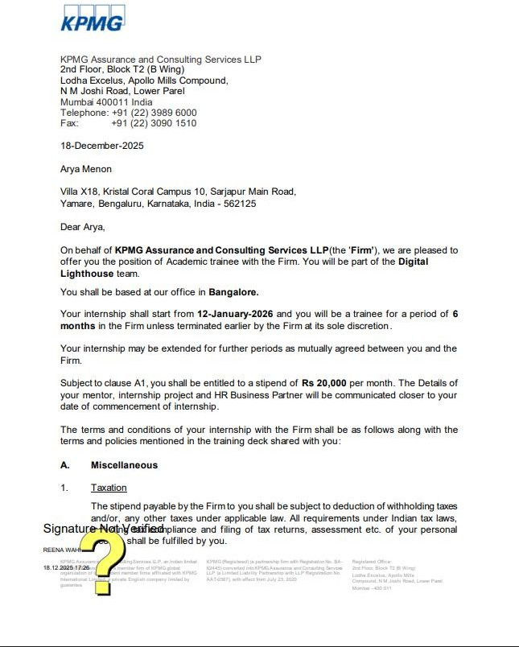

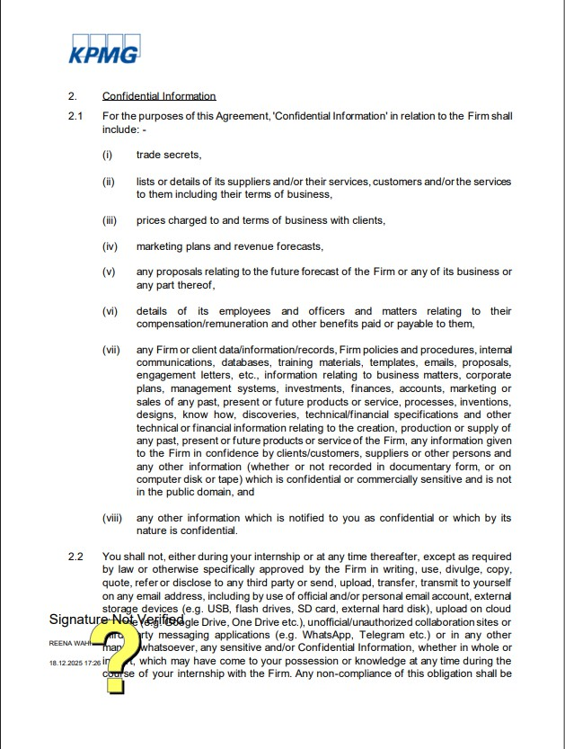

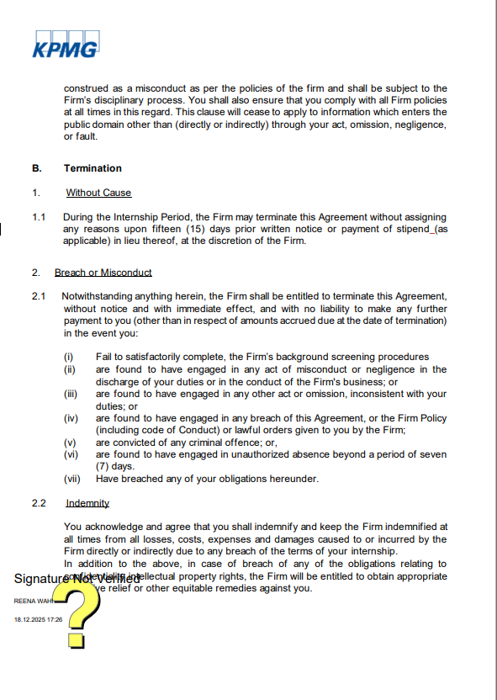

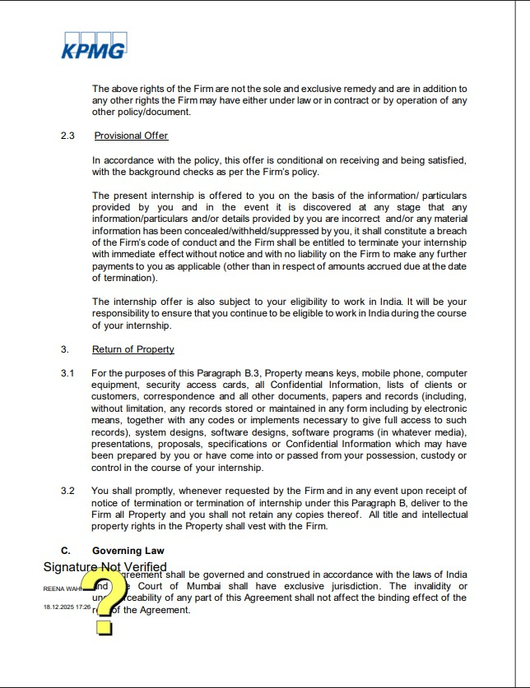

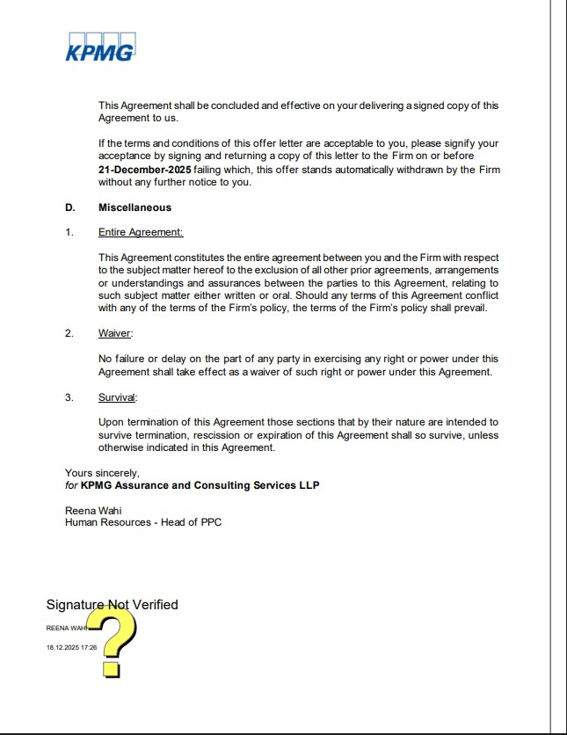

ABSTRACT

This report summarizes my internship experience at KPMG India, a leading global organization specializing in audit, tax, and advisory services. I joined the organization as an Intern Trainee, where I initially underwent a comprehensive one-month training program covering key technologies and concepts such as Salesforce, SDLC (Software Development Life Cycle), Java, Python, .NET, and React. During this training period, I also worked on developing a couple of projects that helped reinforce my understanding of these technologies and their practical applications. Following the training, I was aligned with a team that focuses on leveraging process mining tools such as Make.ai and Celonis to address client requirements and optimize business processes. These tools play a crucial role in analyzing workflows, identifying inefficiencies, and enabling data-driven decision-making for organizations. My responsibilities involved contributing to both technical learning and project-based tasks, gaining exposure to how process mining integrates with enterprise solutions. This internship provided me with valuable experience in modern development practices, process analysis, and emerging technologies. It significantly enhanced my technical and analytical skills while also giving me insight into how innovative tools and methodologies are used to solve real-world business challenges.

INDEX

TABLE OF CONTENTS

CHAPTER NO. TITLE PAGE NO.

ABSTRACT
LIST OF FIGURES LIST OF TABLES
LIST OF ABBREVIATIONS
ix xi xii xiii

- INTRODUCTION 14
  - DOMAIN OVERVIEW 14
  - COMPANY OVERVIEW 14
  - CLIENT OVERVIEW 15
  - TEAM OVERVIEW 15
  - FUNCTIONAL MODULES 16
- PROJECT DESCRIPTION 17
- SOFTWARE REQUIREMENTS SPECIFICATIONS 19
  - SOFTWARE REQUIREMENTS 19
  - HARDWARE REQUIREMENTS 19
  - FUNCTIONAL REQUIREMENTS 19
  - NON-FUNCTIONAL REQUIREMENTS 19
- TECHNOLOGY 20
  - CELONIS 20
  - MAKE AI 21
  - ANTIGRAVITY 22
  - MYSQL 23
- CODING 24
- SCREENSHOTS 26
- CONCLUSION 29
- BIBILIOGRAPHY 30

LIST OF FIGURES

FIG NO. | TITLE | PAGE NO.
6.1 | PAY-TO-INVOICE DASHBOARD | 26
6.2 | AGENT WORK PORTAL | 26
6.3 | INVOICE DASHBOARD | 27
6.4 | PROCESS ANALYTICS | 27
6.5 | AGENT PORTAL DASHBOARD | 28

LIST OF TABLES

FIG NO. | TITLE | PAGE NO.
2.1 | CUSTOMER SEGMENT CLASSIFICATION | 22
5.1 | PRODUCT CATEGORY SALES MIX | 22

LIST OF ABBREVIATIONS

KPI : KEY PERFORMANCE INDICATOR

PQL : PROCESS QUERY LANGUAGE

CHAPTER 1 INTRODUCTION

DOMAIN OVERVIEW – PROCESS MINING

Process mining is a rapidly growing domain that involves the use of data analysis techniques to discover, monitor, and improve real-world business processes by extracting knowledge from event logs available in information systems. It includes analyzing data from multiple sources such as enterprise resource planning systems, customer relationship management tools, workflow systems, and digital activity logs to gain a clear view of how processes actually operate.

One of the most critical areas within process mining is Process Discovery, which focuses on identifying and visualizing the actual flow of activities within a process based on recorded events. Process discovery helps organizations understand how processes are executed in reality, where deviations occur, and what inefficiencies or bottlenecks exist. Conformance checking is a key component of process mining. It involves comparing observed processes with predefined models to detect deviations, compliance issues, and performance gaps. Effective conformance analysis enables businesses to ensure regulatory compliance, optimize workflows, and enhance operational efficiency, ultimately leading to reduced costs and improved organizational performance.

COMPANY OVERVIEW – KPMG India

KPMG India is a leading global professional services firm that provides audit, tax, and advisory services to organizations across various industries. With a strong presence across the country, KPMG India is recognized as a trusted partner for businesses looking to navigate complex regulatory environments and drive growth through data-driven and strategic solutions.
The company offers services in areas such as:

    - Audit and assurance services

    - Taxation and regulatory advisory
    - Risk consulting and management advisory

KPMG India leverages advanced analytics, industry expertise, and innovative technologies to help clients enhance transparency, ensure compliance, optimize operations, and make informed decisions in an increasingly dynamic business environment.

CLIENT OVERVIEW – OPERATIONS TEAM

The Operations Team is a critical internal stakeholder that focuses on transforming raw data into actionable insights to support business decision-making and operational efficiency. This team works across multiple functional areas to ensure that data-driven strategies are effectively implemented within the organization. The team primarily operates in these domains:

    - Data analysis and interpretation – Converting structured and unstructured data into meaningful insights.
    - Performance monitoring – Tracking key metrics and identifying trends to improve efficiency.
    - Decision support – Assisting management in making informed, data-driven decisions.

Team emphasizes accuracy, efficiency, and timely reporting, aiming to enhance overall business performance by leveraging the insights derived from data analytics.

TEAM OVERVIEW – DIGITAL LIGHTHOUSE TEAM

Within the organization, I worked in the Digital Lighthouse team. This team is responsible for delivering data-driven technology solutions that support digital transformation, innovation, and business optimization across industries. The team’s core responsibilities include:

- Developing and implementing data science, machine learning, and cloud-based solutions

- Applying a business-first approach to drive digitalization, innovation, and transformation initiatives

- Leveraging global expertise in data engineering, analytics, and emerging technologies

- Building trusted solutions to drive growth, manage risk, and optimize costs while supporting future-ready business strategies

FUNCTIONAL MODULES

This project focuses on analyzing consumer purchase behavior, product characteristics, and retail performance to generate actionable insights for business decision-making. The system is designed using structured datasets and interactive dashboards.

Product Performance Analysis

This module evaluates product performance based on sales volume, revenue, and demand trends. It helps identify top-performing and underperforming products.

Category Analysis

This module analyzes sales distribution across different product categories such as beverages, snacks, and personal care. It helps understand category contribution and market demand.

Consumer Segmentation

This module groups consumers based on purchase behavior such as frequency and spending patterns. It helps in identifying high-value and low-value customers.

Price vs Sales Analysis

This module evaluates the relationship between product pricing and sales. It helps in understanding price sensitivity and optimizing pricing strategies.

CHAPTER 2 PROJECT DESCRIPTION

Process Mining and Automation System
This project focuses on analyzing consumer purchase behavior, product characteristics, and retail performance to generate actionable insights for business decision-making. The system is designed using structured datasets and interactive dashboards.

Home (Dashboard Navigation Layer)
The Home tab acts as the central interface for navigating across different analytical modules. It provides structured access to key sections such as Process Performance, Case Segmentation, Variant Analysis, and Conformance Insights. This layer ensures ease of use by enabling stakeholders to move across dashboards without interacting with raw event data.

Process Performance Analysis
This module evaluates the performance of products based on sales volume, revenue, and consumer demand.
Products are grouped into performance segments and visualized using charts. It helps in identifying:
  - High-performing products driving revenue
  - Low-performing products needing optimization
  - Seasonal or demand-based variations
This supports product-level decision-making.

Case Segmentation Analysis
This module divides process instances into segments based on execution behavior, duration, and outcomes.
It includes grouping based on:
- Process duration
- Activity frequency
- Outcome variation

Process Variant & Flow Analysis

This module analyzes different process paths and variations followed during execution.
It highlights:
- Most common process variants
- Deviations from standard workflows
- Process complexity and rework loops
This helps organizations understand actual process behavior.

Operational / Functional Performance Analysis

This module evaluates process execution across different departments or operational units.
Key insights include:
- High-performing teams or functions
- Department-level efficiency
- Variation in execution patterns
This supports workflow and resource optimization.

Conformance & Automation Analysis

This module analyzes the alignment between actual process execution and predefined models while integrating automation workflows using Make. It identifies:
- Process deviations and compliance gaps using Celonis
- Automation opportunities and task optimization
- Process improvements visualized through Antigravity dashboards
This is critical for ensuring compliance, enabling automation, and improving overall process efficiency.

CHAPTER 3

SOFTWARE REQUIREMENTS SPECIFICATIONS

Software Requirements
    - Celonis
    - Make.ai
    - Antigravity
    - Mysql

Hardware Requirements
    - Processor: Intel i5 or higher
    - RAM: Minimum 8GB

    - Storage: 256GB SSD or higher

Functional Requirements
    - Data preprocessing and cleaning

    - Value generation
    - Dashboard generation
    - Visualization and reporting

Non-Functional Requirements
    - User-friendly interface
    - Fast processing of large datasets
    - Reliability and consistency

CHAPTER 4 TECHNOLOGY

CELONIS
Celonis was the primary tool used throughout the project for process mining, process analysis, and performance optimization. It played a central role in extracting event logs from enterprise systems and transforming them into structured process models suitable for visualization and decision-making. The datasets used in the process mining project were stored in MySQL and required efficient extraction and transformation before being analyzed. Celonis was used for multiple stages of the workflow, including:
- Event Log Extraction and Preparation: Connecting to MySQL databases and extracting structured event data for analysis.
- Process Discovery: Automatically generating process models from event logs to visualize actual workflows.
- Process Analysis: Identifying bottlenecks, inefficiencies, and deviations in business processes.
Advanced process mining and data modeling concepts were extensively used to perform analysis:
- Data Models: Structuring event logs into cases, activities, and timestamps for accurate process representation
- Process Graphs: Visualizing workflows and identifying execution paths
- Filtering and Aggregation: Applying conditions to focus on relevant process variations

In addition, integration with automation and frontend tools significantly enhanced insights delivery:
- Data Integration: Connecting Celonis outputs with downstream tools for automation and visualization
- Process Visualization: Displaying workflows in structured and interactive formats
- Dynamic Analysis: Supporting real-time process monitoring and updates

The final output was an interactive process view where event log data from MySQL tables was displayed in a clear and structured format for operational and analytica

MAKE AI

Make was used as the automation platform to build and orchestrate workflows between different systems in the process mining pipeline. It is widely known for enabling no-code and low-code automation, making it highly effective for integrating data sources, triggering actions, and streamlining processes.

The role of Make in the project included:

  - Workflow Automation: Designing automated pipelines to transfer data between MySQL, Celonis, and frontend systems.
  - System Integration: Connecting multiple applications and APIs to enable seamless data flow.
  - Event-Based Triggers: Automating actions based on specific process events or updates.

Make offers several features that enhanced the system:

  - Visual Workflow Builder: Enables easy design of complex automation scenarios.
  - API Integration: Supports seamless communication between different platforms.
  - Scalability: Handles multiple workflows efficiently without manual intervention.
Using Make, the following functionalities were effectively implemented:
  - Automated data pipelines for event log processing
  - Real-time synchronization between systems
    - Reduction of manual effort in process execution
The ability to automate repetitive tasks improved efficiency and ensured consistent data flow across the process mining system.

ANTIGRAVITY

Antigravity was used as the frontend platform to build interactive dashboards and visualize process mining insights. It is designed to present complex analytical data in a simple and user-friendly manner, making it effective for business users and stakeholders.
The role of Antigravity in the project included:
- Dashboard Development: Designing interfaces to display process flows, KPIs, and performance metrics.
- Data Integration: Connecting with Celonis outputs to render processed insights.
- Dynamic Visualization: Displaying real-time process analytics in an interactive format.

Antigravity offers several features that enhanced visualization:
•Interactive Dashboards: Enables users to explore process data easily.
- Data Connectivity: Integrates seamlessly with backend and analytics tools.
- User-Friendly Interface: Simplifies interpretation of complex process insights.

Using Antigravity, the following functionalities were effectively implemented:
- Visualization of process flows and bottlenecks
- Real-time updates of process performance metrics

- Intuitive interface for analyzing operational data

The ability to present insights through interactive dashboards made it easier for stakeholders to understand processes, identify issues, and make informed decisions.

MYSQL

MySQL was used as a relational database platform to store, manage, and process structured event log data efficiently. It enabled reliable data storage and fast retrieval required for process mining workflows.
The use of MySQL involved several important steps:
- Data Storage and Management: Storing event logs with case IDs, activities, and timestamps in structured tables.
- Data Retrieval: Executing optimized SQL queries to fetch relevant data for process mining.
- Data Processing: Preparing and cleaning event data before feeding it into Celonis.

MySQL provides several powerful features that were utilized:
- Efficient Query Execution: Supports optimized queries for fast data retrieval.
- Scalability: Handles large volumes of event log data effectively.
- Data Integrity: Ensures consistency and accuracy of stored data.
- Flexible Schema Design: Allows structured storage of process-related datasets.

These features enabled:
- Faster extraction and preparation of event logs for analysis.
- Efficient handling of large datasets required for process discovery.

- Improved overall performance of process mining workflows.

Overall, MySQL significantly improved the efficiency, reliability, and scalability of data operations, making it a critical component in building robust process mining solutions.

CHAPTER 5 CODING
  - PQL (PROCESS QUERY LANGUAGE – PROCESS ANALYSIS)

- Process Throughput Time Calculation
This query is used to calculate the total execution time of a process from start to end for each case. Example: CALC_THROUGHPUT_TIME()
- Activity Frequency Analysis
The query counts how many times a particular activity occurs within the process. Example: COUNT_TABLE("ACTIVITY_TABLE"."ACTIVITY")
- Bottleneck Identification
This query helps identify activities that take the most time in the process. Example: MAX("ACTIVITY_TABLE"."DURATION")
- Case Filtering
This is used to filter process instances based on specific conditions such as long-running cases. Example:
FILTER CALC_THROUGHPUT_TIME() > 10000

  - MYSQL (SQL QUERIES FOR EVENT LOGS)

- Basic Event Log Extraction
Explanation: Retrieves case ID, activity, and timestamp from the event log table.
SELECT case_id, activity, timestamp FROM event_log;

- Activity Count per Case
Explanation: Counts the number of activities executed in each process instance.
SELECT case_id, COUNT(activity) AS activity_count FROM event_log GROUP BY case_id;
- Average Process Duration
Explanation: Calculates the average time taken for process completion.
SELECT AVG(end_time - start_time) AS avg_duration FROM cases;

- Join Operation
Explanation: Combines event log and case tables to retrieve detailed process information.
SELECT e.case_id, e.activity, c.start_time FROM event_log e JOIN cases c ON e.case_id = c.case_id;

CHAPTER 6 SCREENSHOTS
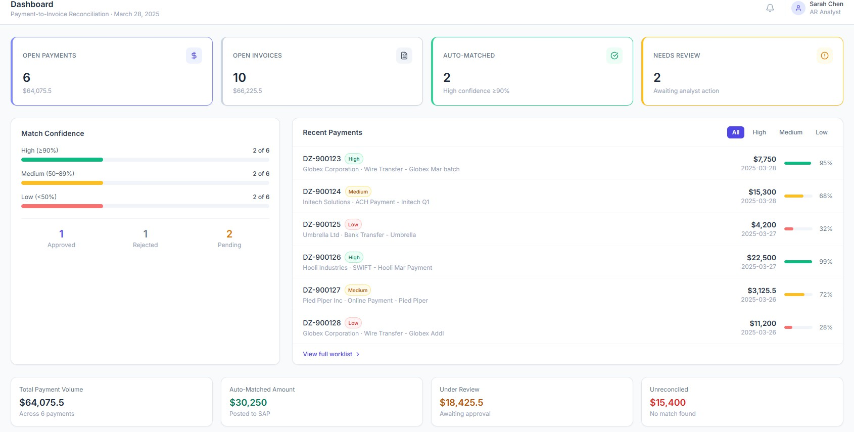

FIG 6.1 PAYMENT-TO-INVOICE DASHBOARD

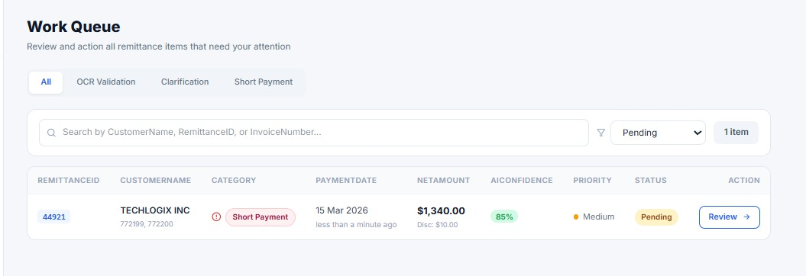

FIG 6.1 AGENT WORK QUEUE PORTAL

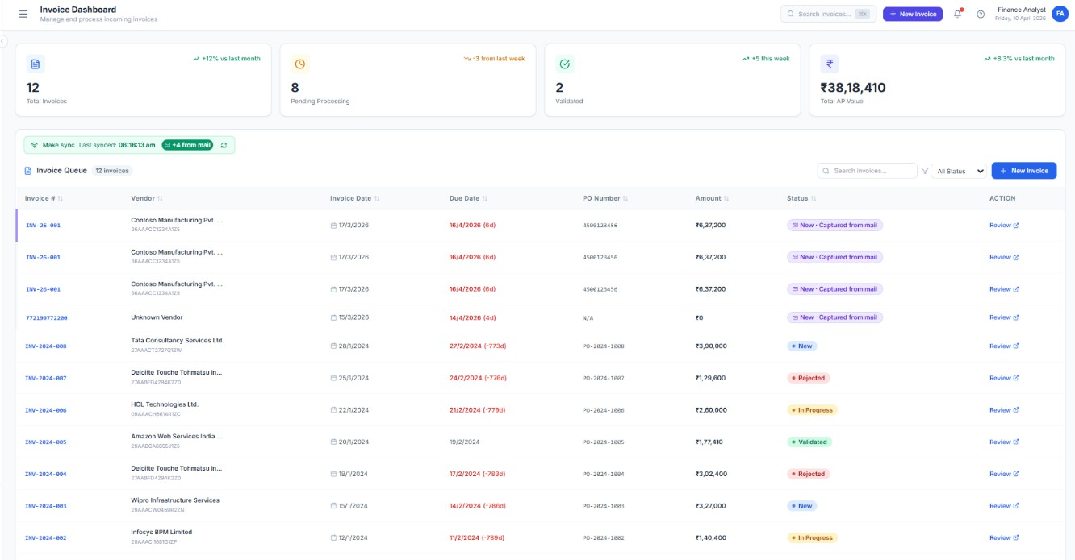

FIG 6.3 INVOICE DASHBOARD

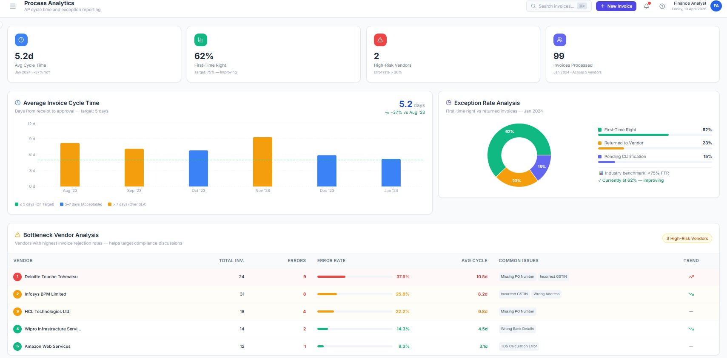

FIG 6.4 PROCESS ANALYTICS

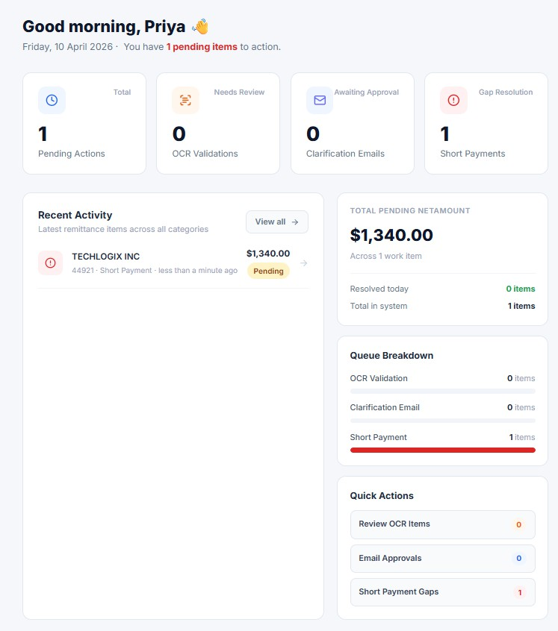
FIG 6.5 AGENT PORTAL DASHBOARD

CHAPTER 7 CONCLUSION
The internship at KPMG proved to be a highly enriching and insightful experience, providing me with a strong foundation in process mining, data-driven analysis, and real-world problem-solving. Being part of a globally recognized organization allowed me to understand how large-scale process intelligence platforms are built and utilized to support operational efficiency. Working within the Digital Lighthouse team gave me exposure to critical aspects such as event log management, system integration, and efficient analysis of business processes across operations.
One of the most significant contributions during my internship was the development of the Process Mining and Automation project. This project enabled me to apply my technical knowledge to solve practical problems involving event log data stored in MySQL. By building functionality to extract, analyze, and visualize process data through process models and dashboards, I was able to ensure that complex workflows were presented in a clear, structured, and user-friendly manner for operational and analytical use.
Throughout the internship, I gained hands-on experience with industry-relevant tools such as Celonis, Make, Antigravity, and MySQL. I learned how to perform process discovery, analyze process performance, automate workflows, and build interactive dashboards for process visualization. These tools enhanced my analytical and technical proficiency and gave me confidence in handling end-to-end process mining solutions within an enterprise environment.
Apart from technical skills, this internship also helped me improve my soft skills and professional competencies. Working in a collaborative team environment taught me the importance of communication, teamwork, and time management. Exposure to a corporate work culture also helped me adapt to professional expectations and develop a disciplined work ethic.
In conclusion, this internship has significantly contributed to my professional growth. It has strengthened my interest in process mining, data analytics, and automation, and provided me with the skills and confidence required to pursue a career in this field.
The knowledge and experience gained during this period will enable me to take on more complex challenges and contribute effectively in a data-driven and technology-driven work environment.

CHAPTER 8 BIBLOGRAPHY

- Books / Academic References:

  - Wil van der Aalst, Process Mining: Data Science in Action, Springer. Used for understanding process mining concepts, event logs, and process discovery techniques.
  - Thomas H. Davenport, Process Innovation: Reengineering Work through Information Technology, Harvard Business School Press. Helped in understanding business process optimization and transformation.
  - Martin Fowler, Patterns of Enterprise Application Architecture, Addison-Wesley. Provided insights into system design, data handling, and scalable application architecture.

- Online Resources / Documentation:

  - Celonis Official Documentation – https://docs.celonis.com/ Reference for process mining, data modeling, and process analysis.
  - Make Documentation – https://www.make.com/en/help Used for workflow automation, API integration, and scenario building.
  - Antigravity Documentation – https://docs.antigravity.com/ Reference for dashboard creation, visualization, and frontend integration.
  - MySQL Official Documentation – https://dev.mysql.com/doc/ Used for database management, SQL queries, and data handling.

- Web References (Process Mining & Automation):

  - Celonis Official Website – https://www.celonis.com/ Reference for process mining solutions and enterprise applications.
  - KPMG – https://kpmg.com Provided context about real-world applications of process mining, digital transformation, and data-driven consulting solutions.

